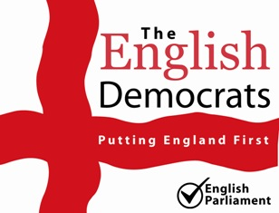  The English Democrats | A Manifesto for Stevenage  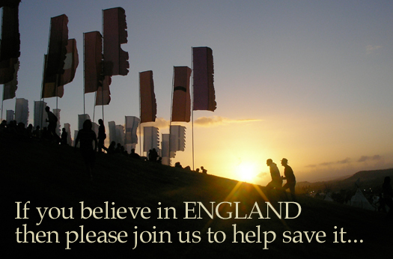
“Those with power to affect our way of life must be answerable to the people. Democracy is much more than the ability to choose, from time to time, between broadly similar parties which compete amongst themselves for power.  Real democracy is measured by the ability of the people to manage their political, economic, physical, and cultural environment.” - English Democrats Manifesto  "There is a forgotten, nay almost forbidden word, which means more to me than any other.  That word is ENGLAND." - Sir Winston Churchill | Hertfordshire English Democrats Stevenage Manifesto 2010  http://www.hertsengdem.org

Table of Contents
Town Centre 1
Housing 1
Jobs 2
Fairness and Equality for England 3
Core Services would be protected. 3
Government Expenditure 3
Families Would Receive Greater Help 3
The Environment 4

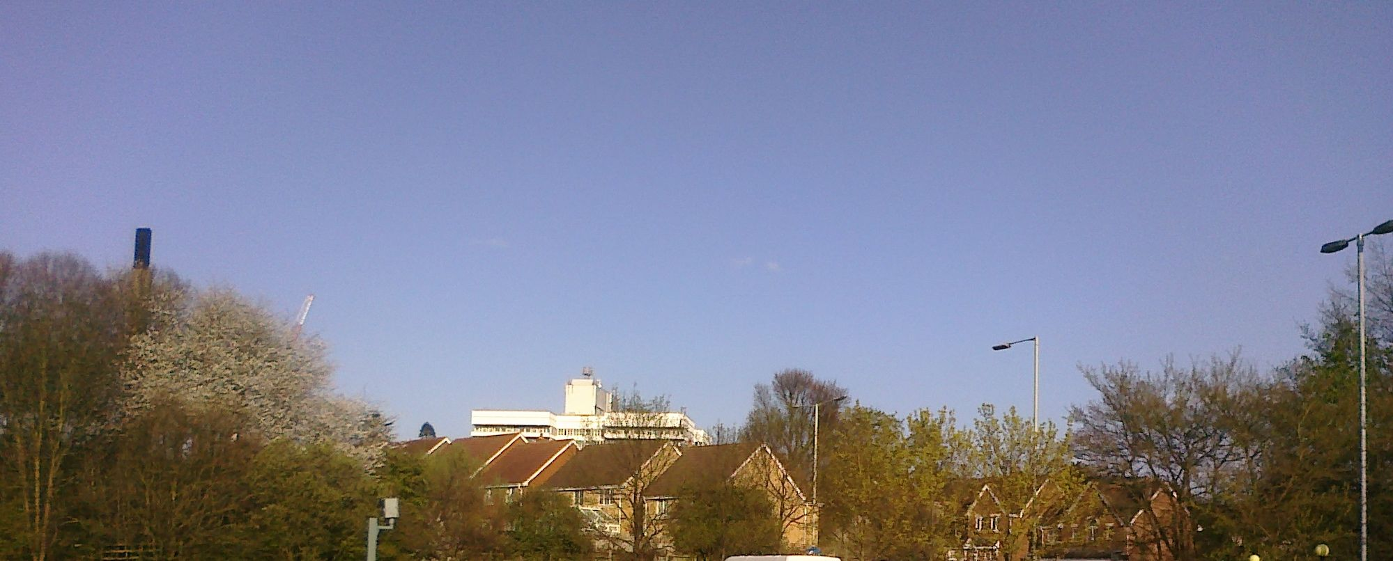

Town Centre
The town centre badly needs redevelopment. I can still remember the excitement of shopping in Stevenage in the second half of the seventies. We had moved ‘up county’ and had been used to shopping in Hatfield. Don’t get me wrong. There was nothing wrong with the Hatfield shopping centre. It was just smaller and not nearly as exciting as Stevenage.
Over the last 35 years the Stevenage centre has grown older. The kids still play there and people still walk through to see what’s happening. But the sense of excitement and achievement is less now. And Stevenage is in danger of following suit. The town needs a sensitive redevelopment to met the needs of the community and businesses in the new millennia.

Housing
The plans of the regional government to extend hosing around Stevenage into the green belt do not make sense.
Last year The Comet newspaper carried a story about water shortages in the area. It seems that in a dry summer the only water flowing in Hertfordshire streams is that from the sewage farms. The article did not say how many times the water had been recycled in this way but if more houses are built where will the water they need come from?
And what happens in a wet winter? Parts of the countryside flood. Often those parts were the new houses will go.
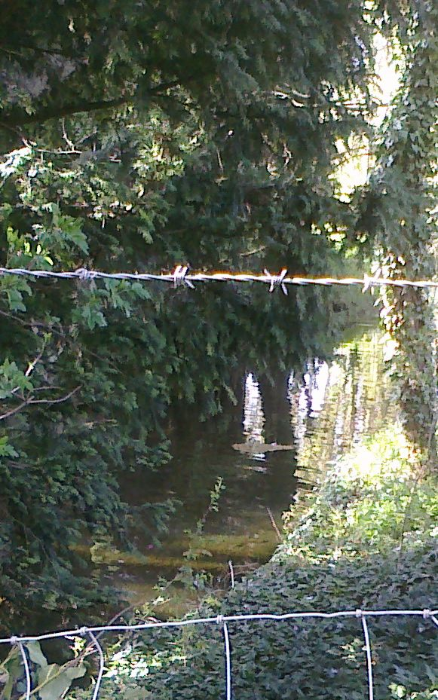
The second question concerns the infra-structure. At the consultation meeting on the housing plans that I attended in 2009 the planners from the region admitted that it was difficult to get any money, at all, for infrastructure.
The people who will suffer from this will be the residents of Stevenage and North Hertfordshire.
The regional housing plans are driven by the immigration policies of New Labour (and the Conservatives and the Lib Dems). The English Democrats will end all mass immigration from non-EU countries and those who are here illegally will have to leave.

Jobs
Gordon Brown has presided over a sell-off of British jobs to foreigners and has managed a huge influx of foreign labour whose sole purpose has been to drive down the wages of British workers. We will end that by putting an end to mass immigration and leaving the EU!
When we entered the EU the UK had a trade surplus with it. We now have a trade deficit of £36 billion annually and this is equivalent to a loss to the other European countries of 700,000 jobs (yes, 700,000). Some of which have been jobs in Stevenage. We will hold a referendum on leaving the EU.
Gordon Brown has repeatedly said he will create British jobs for British workers. Whatever he means by that he does not include English workers! A recent report said that since 1997 of the 1.67 million jobs created, some 1.64 million have gone to people who were not in the country in 1997.
He has been joined in this by the council who are quite happy to employ, in peoples homes, because it is cheap, labour that cannot speak English and does shoddy work. In this the New Labour and the Council are aided and abetted by the unions
There is no economic or moral reason for this so we would end all mass immigration. Immigrants would only be allowed in if no one already here could not do the job, or be trained to do the job, if they had the experience and certificates requires, if they had a crime free history, if they spoke English and if they had a sponsor who would ensure they were covered by private health insurance.
We would bring in legislation to protect key companies from overseas takeover and to reduce the excesses of globalisation.
Under the English Democrats bankers would not be able to get away with large bonuses earned by not lending to companies. We have an extensive programme of bank regulation including splitting banks into their commercial and 'casino' elements, insurance requirements, laws that would enable bankers whose 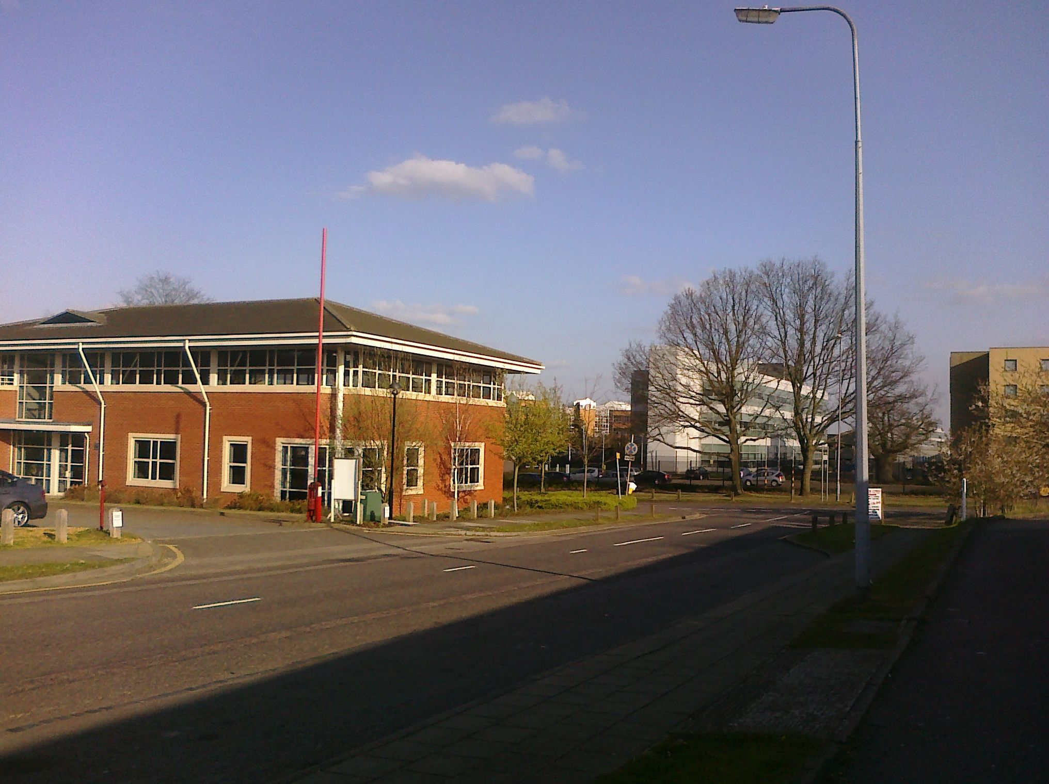banks fail to go to prison, control of financial derivatives and regulation of bonuses. The commercial banks would be focused on lending to companies and individuals so increasing the cash flow that businesses so badly need.

Fairness and Equality for England
Over the last 13 years England has been treated very unfairly leading to the undermining of our health and education services and additional council taxes. We pay on average £300 more than the Scots on Council Tax, our elderly have to pay for their own care, our children are taught in larger classes and if we fall ill we are have to pay for expensive drugs that are free to Scots
We would achieve equality by creating a devolved parliament and government for England, just as the Scots have.
We would give the Welsh and Northern Ireland Assemblies full devolved parliaments and would devolve fiscal responsibility (taxation) to each parliament for its devolved matters (Health, Education, Justice, Transport, Agriculture, People and Society, Statistics and so on). This would lead to a saving to the English taxpayer of £12 billion of subsidy currently given to the Scotland, Wales and Northern Ireland.
The culture and flag of England would be protected and would have to be embedded in all institutions under the English parliament including local authorities. Whilst we are in favour of the celebration of multiple cultures we would get rid of multi-culturalism.
We would get rid of unnecessary political correctness and officious health and safety practices.

Core Services would be protected.
We would protect core services in output terms, meaning that the quality and quantity of services would be maintained or improved, but provided more efficiently and the government. We are all familiar with the stories of outlandish salaries, extortionate consultancy fees and inefficient work practices.
We would introduce the technique of zero-based budgeting (ZBB) to help prioritize expenditures. Those expenditures that are strongly related to service delivery would rank higher. Those that were not would have a low priority. Budgets would be allocated, starting with the highest priority until the budget limit had been reached. Activities below this limit would be discontinued. However since ZBB allows for high value activities to be increased there will be additional employment opportunities in those areas so limiting the job losses, although there would still be some. The budget limit would be set incorporating Labour’s target of £50 billion efficiency savings.
Core services such as free care for the elderly, health, education, child protection, services for the disabled and the police would have a higher value thus ensuring they came higher up the priority list.

Government Expenditure
Our budget for England would include the savings from devolution for England of £12 billion, the savings from leaving the EU estimated at £30 billion and the Labour government's own efficiency savings of £52 billion totaling in all £94 billion. This would eliminate the structural deficit in government spending.
Increased tax receipts that arose as the economy improved would be used to start paying back the national debt.

Families Would Receive Greater Help
Increasing affordable child care for those who wish to work, increasing the availability of social housing and by bringing in regulations to improve the flexibility of the labour market.
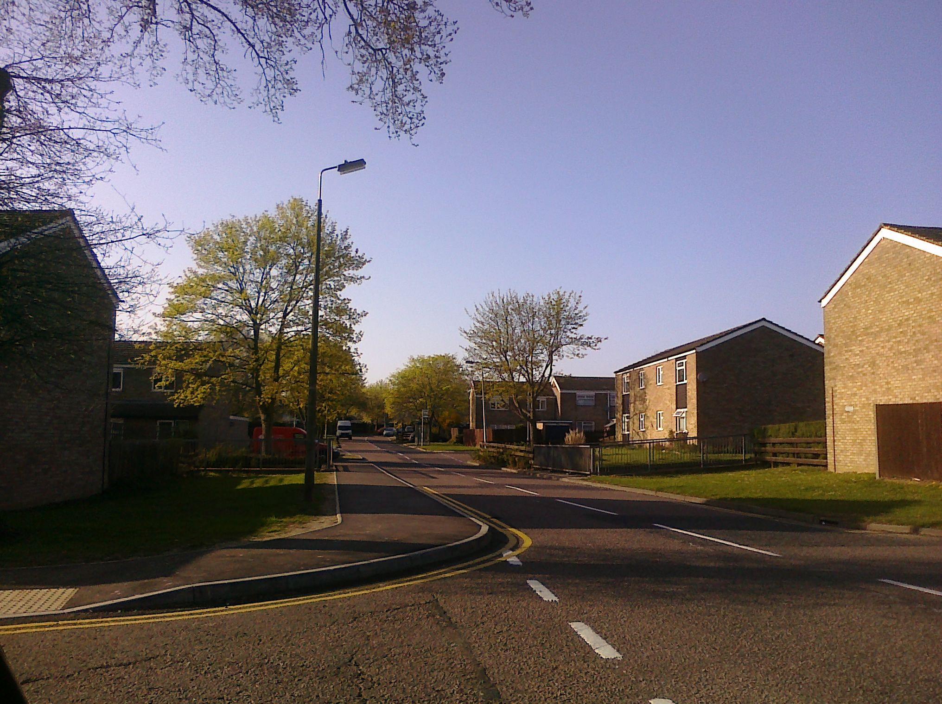
Survey after survey had shown that married couples are more productive in the economy than cohabiting couples.

Due to less violence in the relationship there is a lower need for social services, the police and courts and married relationships last longer putting less of a strain on housing. As a party we are also committed to marriage as a sound foundation for society. For all these reasons we would introduce a transferable personal tax allowance between spouses.

We would stop charging students fees for higher education. Graduates pay higher taxes already and there is no need to create a reason for taxing them highly at the beginning of their life. This move will make higher education more appealing to all especially those who are less well of and will enable couples to have a higher sense of financial security as they start out on their life together.

The Environment
The driving force for us for a low carbon and sustainable future is the believe that “Each generation holds the environment in trust for future generations. We should not leave them to bear the cost of our selfish and short-sighted behaviour.

As such our proposals for the environment, that include renewable energy and trials of fuel-cell technology, are focused on communities, such as Stevenage, and are of a high priority.

Notes

